**27th SPRING SHOW AND PLANT SALE**

SATURDAY, 12th April 2025 at 2.00pm

## ASTON CLINTON SCHOOL

TWITCHELL LANE

HP22 5JJ

TROPHIES PRESENTED AT 4.00 p.m.

by

Nick Harris

Admission £1 (at the door)

# How to Get There

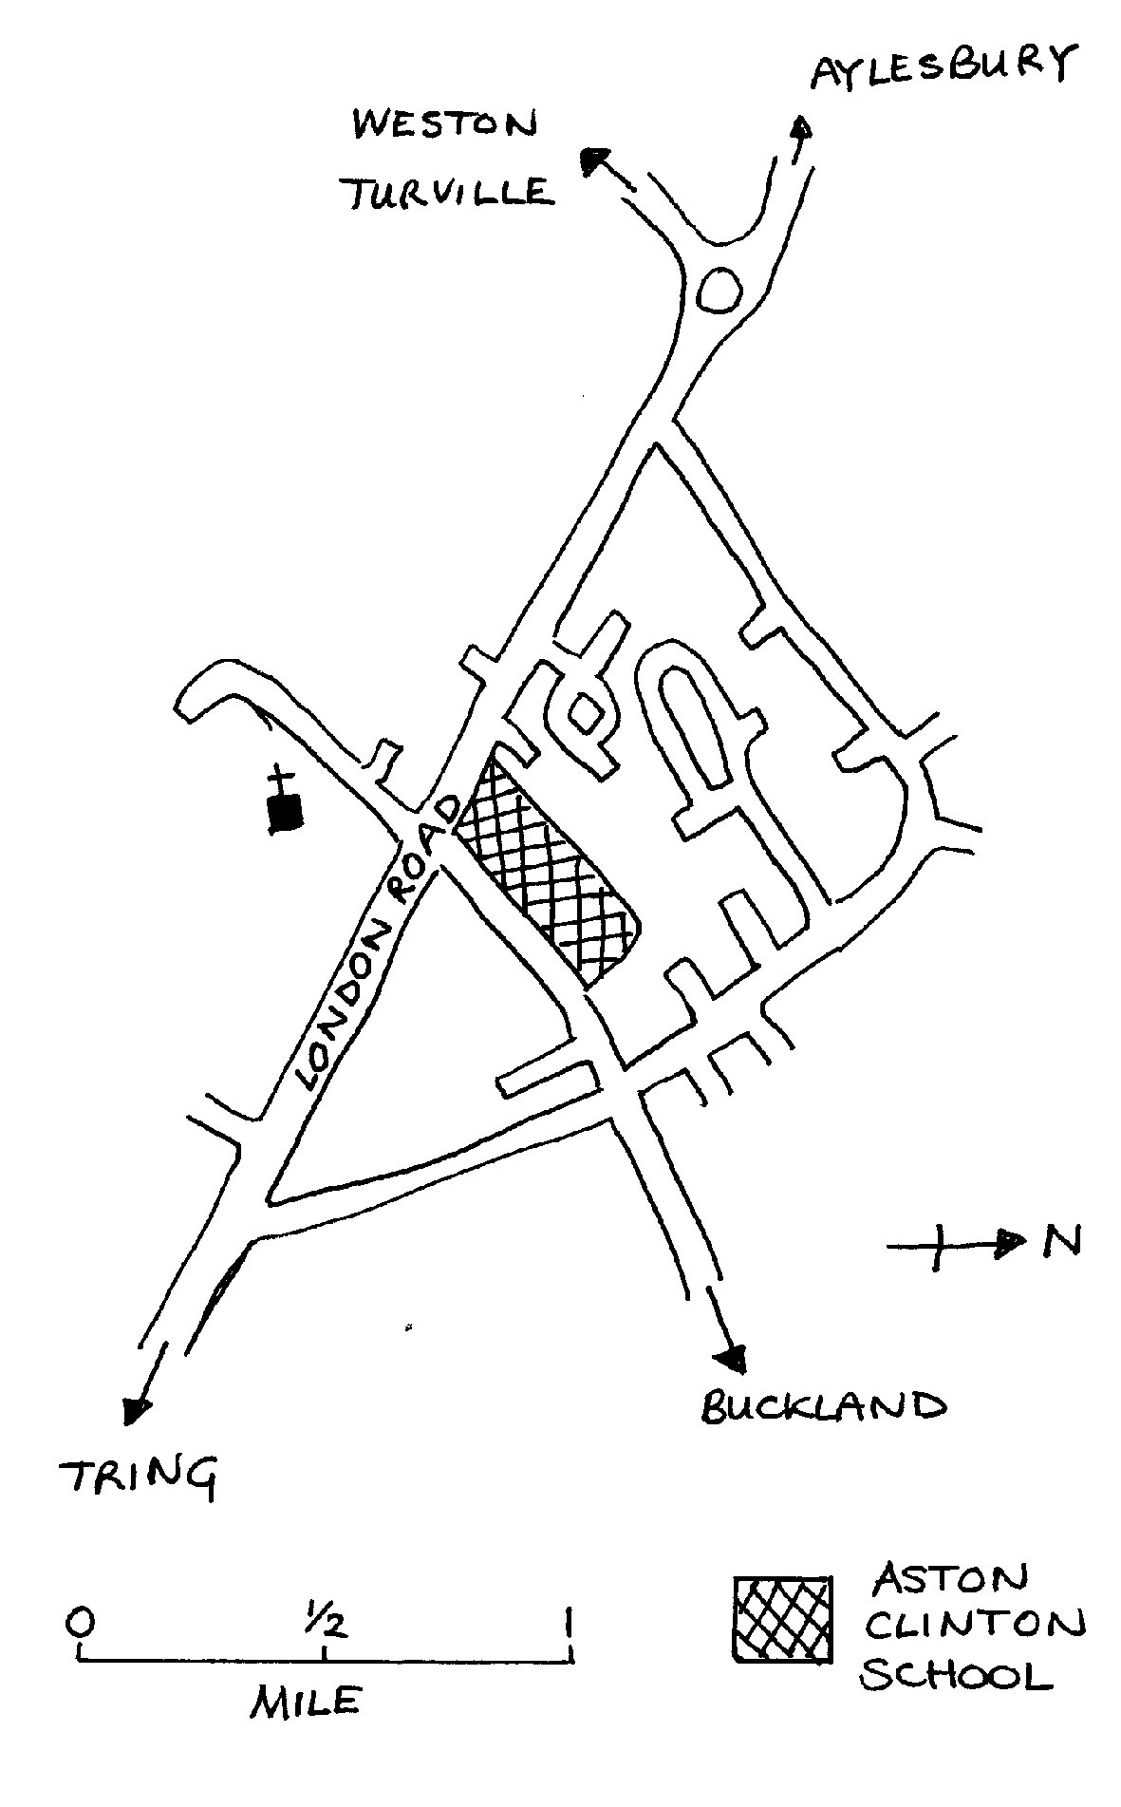

Organised by

**ASTON CLINTON, BUCKLAND AND DRAYTON BEAUCHAMP HORTICULTURAL SOCIETY**

Affiliated to The Royal Horticultural Society

**SHOW INFORMATION**

The Spring Show is a great local event celebrating all things plants, flowers, cooking and arts & crafts. The aim is to encourage a wide range of participants from within all the local communities to share exhibits they have either grown, made, cooked or created

**How To Enter**

1. complete the entry form [www.astonclintonhorticulturalsociety.co.uk/spring-show](http://www.astonclintonhorticulturalsociety.co.uk/spring-show)
2. this form can be submitted

* attached and via email [– *shows@astonclintonhorticulturalsociety.co.uk*](mailto:–%20shows@astonclintonhorticulturalsociety.co.uk)
* in person – printed and brought to entry night at the Anthony Hall, Thursday 10th April 2025 6pm to 7.45pm

Please ensure that entry forms are received on or before Thursday 10th April 2025.

All entries are free.

We do not accept telephone entries

**Show Secretary –** Chris Dunbar

**On The Day**

7.30am – 10.30am EXHIBITOR SET UP

11.00am JUDGING

(ALL persons, other than Show Stewards,

MUST VACATE the area by 10.30am)

2.00pm SHOW OPENS

Teas, Raffle, Plants and Produce stalls

4.00pm PRESENTATION OF CUPS AND TROPHIES by Nick Harris

Followed by RAFFLE

The distribution of children's rosettes

will be from 3.00pm onwards

**THE SOCIETY WEB SITE IS** http://www.astonclintonhorticulturalsociety.co.uk/

### **SECTION 1**

**SECTION 1A – (Vases supplied)**

**Specifically aimed at novices, children and the casual grower. Exhibition growers should not enter section 1A.**

1. **“Grow for Show”** - Pot size 12 inches or less. Cultivar **– Jetfire Division** 6y/o(any number of bulbs, judged for effect)

**Junior Daffodil Trophy** (6 to 14 years) **most points in classes 2-3**

2. One daffodil, any colour, in one vase.

3. Three daffodils, any colour, in one vase.

*Children’s age to be marked on exhibitor’s card*

**The Doug Warr Novice Trophy – most points in classes 4-6**

4. One single bloom, any colour, any cultivar,

5. Three single blooms, any colour, any cultivars

6. Three multi-blooms any colour, any cultivars i.e. each stem has multiple blooms

**SECTION 1B**

**Open to everyone, all growers welcome if in doubt please do not hesitate to ask**

**Daffodils - Division 1** (Trumpet daffodils)

7. One Bloom, yellow/yellow

8. One Bloom, multi-colour

9. One Bloom, white/white

10. Three Blooms, yellow/yellow

11. Three Blooms, multi-colour

12. Three Blooms, white/white

**Daffodils - Division 2** (large cupped daffodils)

13. One Bloom, yellow/yellow

14. One Bloom, multi-colour

15. One Bloom, white/white

16. Three Blooms, yellow/yellow

17. Three Blooms, multi-colour

18. Three Blooms, white/white

**Daffodils - Division 3** (small cupped daffodils)

19. One Bloom, Small cup, any cultivar.

20. Three Blooms, Small Cup, any cultivar or cultivars.

**Daffodils - Division 4** (double daffodils)

21. One Bloom, Double, any cultivar.

22. Three Blooms, Double, any cultivar or cultivars.

***(Classes 24 to 30: Exhibitor’s Choice)***

24. Three Stems, Division 5**,** Triandrus

25. Three Blooms, Division 6**,** Cyclamineus

26. Three Stems, Division 7**,** Jonquilla

27. ThreeStems, Division 8**,** Tazetta

**The Martin Johnston Daffodil Shield** for best bloom in Division 11 (**classes 29 and 30**)

29. One Stem, Division 11

30. Three Stems, Division 11

31. **The Pink Daffodil Trophy** - for the best daffodil with pink in the cup. One Bloom in a vase, selected from Divisions 1- 4

32. **The Six Daffodils Cup** (must include at least one from each division)

Six cultivars**,** one bloom of each selected from Divisions1 to 4, to be staged in **two** vases

33**. The Pauline Rust Daffodil Trophy**

**Three** vases each containing three stems or blooms.  Please choose from the following divisions -

              1 vase, 3 stems from Division 5

              1 vase, 3blooms from Division 6

              1 vase, 3 stems from Division 7

                           1 vase, 3stems from Division 8

*If in doubt please ask*

34. **The Society's Bloom Daffodil Trophy**

Onebloom of **Night Cap** Division 2(this year’s cut bloom) (two entries allowed)

35. **The Elizabeth Cup** Three daffodils selected from Divisions 1 to 4 staged in one vase any cultivar or cultivars

36. **White Daffodil Cup** Six White cultivar or cultivars from Divisions1 to 3**,** to be staged

in two vases, *exhibitor’s choice*

37. **The Frank Pullin Trophy** Division 3 Daffodil

Six cultivar or cultivars, all Division 3, two vases of three *exhibitor's choice*

38. **The Penrice Cup** One bloom of **Kiwi Sunset Division 4**

39. **The Master Daffodil Trophy**

Six distinct cultivars, one bloom of each selected from Divisions 1 to 4, to be staged one bloom per vase.

.

**SECTION 2 Spring Flowers (***Vase to be supplied by the exhibitor)*

40. Basket of 6-12 Daffodils (one or more varieties) with daffodil foliage and moss, 8'' (20cm) max. diameter basket

41. Spring Collection of cut flowers in a vase, any variety, display not exceeding 18" (46 cm) across

42. Vase of Polyanthus, 6 stems, any colour

43. Vase of Hyacinths, 3 any colour

45. Grape Hyacinths, 6 spikes in a vase

46. Flowering Shrub, 3 stems, one or more variety

47. Tulips, 1 bloom with tulip foliage, in a vase

48. Tulips, 3 blooms with tulip foliage, one variety in a vase

50. Pansies/violas, 6 in a saucer or small plate

51. Spring bulbs in pan or pot, 12'' (30cm) max, any variety

51a Hellebores - Floating heads in a bowl, max size 10 inches (25.5cm) in diameter

**Additional Notes for Daffodil Exhibitors –**

Section one single bloom classes- Exhibitors may enter up to two exhibits, Single bloom classes which are 7,8,9,13,14,15,19,21,29,31,34, & 38

Additional staging time will be available on Friday 11th between 7pm & 9.30pm

# **SECTION 3 Floral Art**

52. **Novice** **class** Floral arrangement with a candle or candles. Maximium size 30 cms 12’ diameter *(Not open to anyone who has previously gained a first prize in classes 53-56)*

53. Floral arrangement in an Egg Cup

54. Arrangement of Spring flowers for the centre of a table, to be viewed from all sides

55**.** Floral Art – “Spring Vibes”

56. A Spring arrangement in Basket width 60cms (24”) Max Length 76cms (30”) Max Height 60cms (24”)

**NOTES:**

1. The plant material for Classes 52, 53, 54, 55, & 56 need not have been grown by the Exhibitor

2. Space provided for Class 55 will be a base area 60cms (24") x 60cms (24"), with a height of 76cms (30"), any

natural flower and plant material with suitable accessories, birds etc may be used in classes 54, 55 & 56. *For*

*class 55 the arrangement should fill the niche*.

**SECTION 4 Domestic**

57. Jar of lemon curd

58. Jar of marmalade

59. Jar of chutney

60. Jar of soft fruit jam

61. Cornish pasty, short crust pastry

62. Six eggs from fowls belonging to the exhibitor

63. Meringues, 3 pairs filled

64. Chocolate Brownies – own recipe, 5 pieces cut

65. Fruit Tea bread, as per recipe on page 7

66. 5 Cookies/Biscuits own recipe

67. Victoria sandwich, as per recipe on page 7

# **SECTION 5 Children**

## ***14 years or under - age must be marked on the ENTRY CARD of all children's exhibits***

**Children aged 8 years and under**

69. Collage of an animal using coloured paper

70. Make a model from any medium e.g. Lego. Not to exceed A4 sheet of paper in size

71. An arrangement of flower heads in a saucer

72. Decorate a flowerpot with spring colours

72a Storybook Garden – Create a garden based on your favourite story or fairy tale using items to reflect your choice

**Children aged 9-14 years**

73. Make a model from any medium e.g. Lego. Not to exceed A4 sheet of paper in size

74. Upcycled Planters – design a planter from old items e.g. broken toys, tin cans, old wellies

75. An arrangement of flower heads in a saucer not exceeding 46cms (18”)

76 Three animal shaped biscuits – any recipe

(Please note that children can enter adult classes but do not need to mark age on entry cards)

**SECTION 6 Handicrafts**

77. A hand-knitted article

78. An item of embroidery or cross-stitch

79. An article made of fabric using a technique other than those used in classes 77, 78 and 82

80. A drawing or painting, any topic, any medium. (Not to exceed 60cm (24'') x 66cm (26'') overall ,

*The frame will not be judged*

81. An item made of wood not to exceed 60cm (24'') all round including height

82. A crocheted item

**SECTION 7 Photography**

**Children 9 to 14 years**

83. **Bird/Birds** photograph not to exceed 20cm x 15 cm (8” x 6”)

Please state the child’s age on the exhibit entry card

**Adults (15 years upwards)**

84. Coloured photograph of **Winter Scene**

Not to exceed 20cm x 15cm ((8'' x 6''), mounted not framed – ***see note below***

85. Coloured photograph **My Favourite Pothole** Not to exceed 20cm x 15cm (8” x 6''),

mounted not framed – ***see note below***

87 Photography Master Class. Coloured photograph **The Sky**

Not to exceed 20cm x 15cm (8” x 6”) mounted not framed -see note below

**NOTE** ***The mounts should not exceed 12.5mm (1/2”) around the photograph***

**RECIPE** **FOR Fruit Tea Bread**

**Class 65**

**Ingredients**

350g (12 oz.) mixed fruit

350ml (12 fl oz.) tea

2 eggs

270g (10 oz.) self-raising flour

200g (7 oz.) brown sugar

1 tspn cinnamon

**Method**

1. Add dried fruit to tea and leave to soak overnight.

2. Mix in 2 beaten eggs, self-raising flour, sugar and cinnamon.

3. Put mixture in 1 x 2lb loaf tin. Cook in oven at 325°F, 170°C or gas mark 3 for 1½ hours

**Recipe for Victoria Sandwich**

**Class 67**

**Ingredients**

3 large eggs, their weight in margarine, caster sugar and self-raising flour

raspberry jam, pinch of salt

**Method**

1. Grease and flour two sandwich tins (18cms/7 inch).

2. Cream the margarine in a bowl.

3. When soft and creamy, add the sugar and whip until light and fluffy.

4. Beat the eggs adding them gradually to the mixture.

5. Finally, add the sifted flour and salt and mix together.

6. Divide between the two tins, spreading the mixture so that the

sides are a little higher than the centre.

7. Bake for 20-25 minutes at 350°F-375°F or 180°C-190°C.

8. Fill with raspberry jam, dust with caster sugar

### **TROPHIES, DIPLOMAS & MEDALS**

|  |  |
| --- | --- |
| **Section 1 The ‘Grow for Show’ Trophy**  *Exhibitor gaining most points in**class 1* |  |
| **Junior Daffodil Shield**  *Children aged 6 to 14 years, Class 2 & 3* | **The Doug Warr Novice Daffodil Trophy**  *Exhibitor gaining most points in novice classes 4,5&6* |
| **The Martin Johnston Daffodil Shield** *Best bloom in Division 11- classes 29 and 30* | **The Violet Rolfe Daffodil Shield** *Exhibitor gaining most points in Section 1 classes 7-27* |
| **The Pink Daffodil Trophy**  *gaining most points in class 31* | **Six Daffodils Cup** *gaining most points in class 32* |
| **The Pauline Rust Daffodil**  *gaining most points in class 33* | **The Society’s Bloom Daffodil Trophy** *Exhibitor gaining most points in class 34* |
| **The Elizabeth Cup**  *gaining most points in class 35* | **The White Daffodil Cup**  *Exhibitor gaining most points in class 36* |
| **The Frank Pullin Division 3 Daffodil Trophy** *Exhibitor gaining most points in class 37* | **The Penrice Cup**  *Exhibitor gaining most points in class 38* |
| **The Master Daffodil Trophy** *Exhibitor gaining most points in class 39* | The Daffodil Society Bronze Medal and Diploma for  **Best Bloom in Show** (to be kept by the winner) |
| *Best Bloom in Show, Division* 1 *(Certificate)*  *Best Bloom in Show, Division* 2 *(Certificate)*  *Best Bloom in Show, Division* 3 *(Certificate)*  *Best Bloom in Show, Division* 4 *(Certificate)* | *Best Bloom or Stem in Show, Division* 5 to 11 *(Certificate)*  *Best Vase of 3 Daffodil Society Diploma*  *Best Vase of 3 for Novices Daffodil Society Diploma* |
| **Section 2 The Spring Cup for Flowers**  *Exhibitor gaining most points in Section 2* | **Section 2 The John Seaton Tulip Cup** *Exhibitor gaining most points in classes 47 & 48* |
|  | **Section 2 The Stewkley Cup**  *Winner of class 51a* |
| **Section 3 The George White Floral Art Shield**  *Exhibitor gaining most points in classes 53 to 56* | **Section 4 The** **Lorna Price Domestic Challenge Plate**  *Exhibitor gaining most points in Section 4* |
|  | **Section 5 The Lorna Price Cup: Children 8**  **and under**  *Child gaining most points in Section 5, classes 69 to 72* |
| **Section 5 The Savigar Cup: Children 9 to 14**  *Child gaining most points in Section 5,*  *classes 73 to 76* | **Section 6 The Park Farm Handicraft Challenge Plate**  *Exhibitor gaining most points in Section 6* |
| **Section 7 The Cup for the Best Photo in show** |  |

##### **GENERAL RULES OF EXHIBITION**

1. Judging will be in accordance with the Daffodil society rules. All daffodil exhibits are to be marked with the name of the cultivar where possible.
2. Exhibits must be the property of the exhibitor. All garden produce exhibited must have been in the possession of the exhibitor for at least two months before the show and any trophies awarded contrary to the rules, will be forfeited and awarded to the competitor next in merit in the same class.
3. A competitor can only enter ONE exhibit in each class except where stated. Each exhibit must be entered by an individual competitor.

4. All entries must be made on the Entry Form and submitted by email, posted or made in person on entry night **at Anthony Hall on Thursday 10th April from 6.00 to 7.45pm**.

5. Entry of exhibits are free for all.

6. Exhibit cards will be available from the Show Secretary on the day of the Show.

The cards will be numbered in order to distinguish the class of exhibit and must be placed face downwards on, or in front of, the exhibit when staged.

7. Flower class exhibitors must see that all stems reach the water. The exhibitor Classes 2 to 39 will have

bikini vase provided which are not to be removed. Moss will be provided by the society to assist in

packing Also see note 8

8. The committee will not be responsible for any loss or damage to the exhibits from whatever source.

Every care will be taken by the officials but all exhibits must be shown at the sole risk of the owner.

On the morning of the show the Exhibition Area will be open at 7.30am to allow for early staging. See

note on page 4 for extra staging times

9. All Exhibits must be staged not later than **10.30 am**

10. Judging will commence at 11.00 am

11. The judges may withhold any award in any class with insufficient entries, or where the exhibits are of

indifferent quality. The judge’s decision is final.

12. Points towards trophies will be awarded as follows: **1st 3** pts, **2nd 2** pts, **3rd** 1pt.

13. **All exhibits must be left on the show bench until 4.30 pm**.

14. The trophies of the Society are awarded as indicated on page 8 of the schedule. All trophies must be returned in good condition to the Show Secretary not later than **Thursday 10th April 2025**

15. Exhibitors who use their own vases are responsible for ensuring they are clearly identified.

16. All exhibitors should refrain from staging on the exhibition area, please use staging table provided

(This does not include the Floral Art section).

17. Any queries to be discussed with the show secretary and can be logged in the Query book