28th SPRING SHOW AND PLANT SALE

SATURDAY, 28th March 2026 at 2.00pm

ASTON CLINTON SCHOOL
TWITCHELL LANE
HP22 5JJ

TROPHIES PRESENTED AT 4.00 p.m.

by

Marion Mason – Chair of Aston Clinton Parish Council

Admission £1 (at the door)

How to Get There
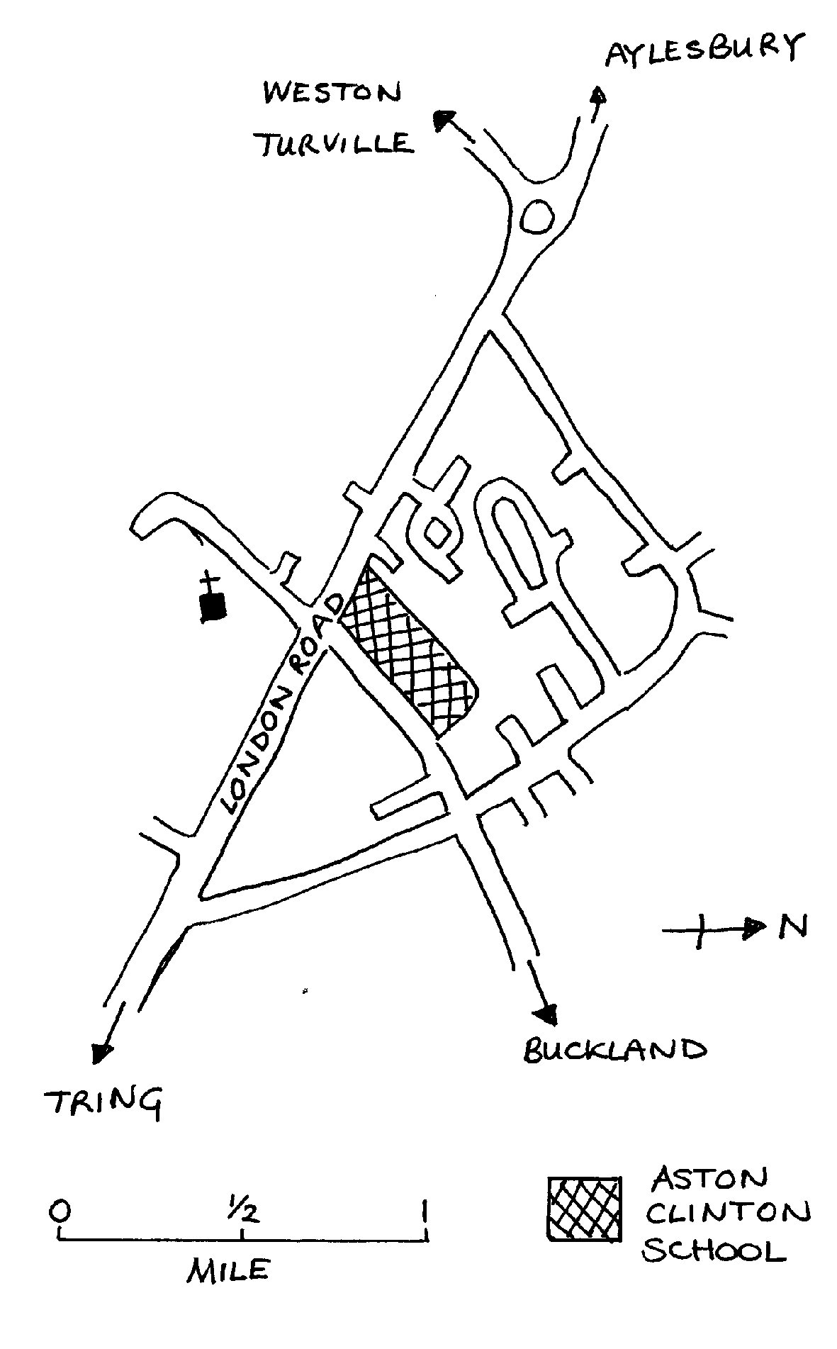

Organised by

ASTON CLINTON, BUCKLAND AND DRAYTON BEAUCHAMP HORTICULTURAL SOCIETY

Affiliated to The Royal Horticultural Society

SHOW INFORMATION

The Spring Show is a great local event celebrating all things plants, flowers, cooking and arts & crafts. The aim is to encourage a wide range of participants from within all the local communities to share exhibits they have either grown, made, cooked or created

How To Enter

- complete the entry form www.astonclintonhorticulturalsociety.co.uk/spring-show
- this form can be submitted
- attached and via email – shows@astonclintonhorticulturalsociety.co.uk
- in person – printed and brought to entry night at the Anthony Hall, Thursday 26th March 2026 6pm to 7.45pm

Please ensure that entry forms are received on or before Thursday 26th March 2026.
All entries are free.
We do not accept telephone entries

Show Secretary – Chris Dunbar

On The Day

7.30am – 10.30am EXHIBITOR SET UP
11.00am JUDGING
(ALL persons, other than Show Stewards,
MUST VACATE the area by 10.30am)
2.00pm SHOW OPENS
Teas, Raffle, Plants and Produce stalls
4.00pm PRESENTATION OF CUPS AND TROPHIES by Marion Mason
Followed by RAFFLE

The distribution of children's rosettes
will be from 3.00pm onwards

THE SOCIETY WEB SITE IS http://www.astonclintonhorticulturalsociety.co.uk/

SECTION 1

SECTION 1A – (Vases supplied)

Specifically aimed at novices, children and the casual grower. Exhibition growers should not enter section 1A.

- “Grow for Show” - Pot size 12 inches or less. Cultivar – Jetfire Division 6y/o (any number of bulbs, judged for effect)

Junior Daffodil Trophy (6 to 14 years) most points in classes 2-3

2. One daffodil, any colour, in one vase.
3. Three daffodils, any colour, in one vase.
Children’s age to be marked on exhibitor’s card

The Doug Warr Novice Trophy – most points in classes 4-6

4. One single bloom, any colour, any cultivar,
5. Three single blooms, any colour, any cultivars
6. Three multi-blooms any colour, any cultivars i.e. each stem has multiple blooms

SECTION 1B

Open to everyone, all growers welcome if in doubt please do not hesitate to ask

Daffodils - Division 1 (Trumpet daffodils)
7. One Bloom, yellow/yellow
8. One Bloom, multi-colour
9. One Bloom, white/white
10. Three Blooms, yellow/yellow
11. Three Blooms, multi-colour
12. Three Blooms, white/white
Daffodils - Division 2 (large cupped daffodils)
13. One Bloom, yellow/yellow
14. One Bloom, multi-colour
15. One Bloom, white/white
16. Three Blooms, yellow/yellow
17. Three Blooms, multi-colour
18. Three Blooms, white/white
Daffodils - Division 3 (small cupped daffodils)
19. One Bloom, Small cup, any cultivar.
20. Three Blooms, Small Cup, any cultivar or cultivars.
Daffodils - Division 4 (double daffodils)
21. One Bloom, Double, any cultivar.
22. Three Blooms, Double, any cultivar or cultivars.
(Classes 24 to 30: Exhibitor’s Choice)
24. Three Stems, Division 5, Triandrus
25. Three Blooms, Division 6, Cyclamineus
26. Three Stems, Division 7, Jonquilla
27. Three Stems, Division 8, Tazetta

The Martin Johnston Daffodil Shield for best bloom in Division 11 (classes 29 and 30)
29. One Stem, Division 11
30. Three Stems, Division 11

31. The Pink Daffodil Trophy - for the best daffodil with pink in the cup. One Bloom in a vase, selected from Divisions 1- 4 (Class open to Society Members only)

32. The Six Daffodils Cup (must include at least one from each division)
Six cultivars, one bloom of each selected from Divisions 1 to 4, to be staged in two vases
33. The Pauline Rust Daffodil Trophy
Three vases each containing three stems or blooms. Please choose from the following divisions -
1 vase, 3 stems from Division 5
1 vase, 3 blooms from Division 6
1 vase, 3 stems from Division 7`
1 vase, 3 stems from Division 8
If in doubt please ask
34. The Society's Bloom Daffodil Trophy (Class open to Society Members only)
One bloom of Sealing Wax Division 2 (this year’s cut bloom two entries allowed)
35. The Elizabeth Cup Three daffodils selected from Divisions 1 to 4 staged in one vase any cultivar or cultivars (Class open to Society Members only)
36. White Daffodil Cup Six White cultivar or cultivars from Divisions 1 to 3, to be staged
in two vases, exhibitor’s choice
37. The Frank Pullin Trophy Division 3 Daffodil
Six cultivar or cultivars, all Division 3, two vases of three exhibitor's choice
38. The Penrice Cup One bloom of Colour Run Division 2
39. The Master Daffodil Trophy
Six distinct cultivars, one bloom of each selected from Divisions 1 to 4, to be staged one bloom per vase.
39a One stem, Division 9

.
SECTION 2 Spring Flowers (Vase to be supplied by the exhibitor)

40. Basket of 6-12 Daffodils (one or more varieties) with daffodil foliage and moss, 8'' (20cm) max. diameter basket
41. Spring Collection of cut flowers in a vase, any variety, display not exceeding 18" (46 cm) across
42. Vase of Polyanthus, 6 stems, any colour
43. Vase of Hyacinths, 3 any colour
45. Grape Hyacinths, 6 spikes in a vase
46. Flowering Shrub, 3 stems, one or more variety
47. Tulips, 1 bloom with tulip foliage, in a vase
48. Tulips, 3 blooms with tulip foliage, one variety in a vase
50. Pansies/violas, 6 in a saucer or small plate
51. Spring bulbs in pan or pot, 12'' (30cm) max, any variety
51a Hellebores - Floating heads in a bowl, max size 10 inches (25.5cm) in diameter

Additional Notes for Daffodil Exhibitors –

Section one single bloom classes- Exhibitors may enter up to two exhibits, Single bloom classes which are 7,8,9,13,14,15,19,21,29,31,34,38 ,39a
Additional staging time will be available on Friday 27th March between 7pm & 9.30pm

SECTION 3 Floral Art

52. Novice class Floral arrangement with a candle or candles. Maximum size 30cms 12” diameter (Not open to anyone who has previously gained a first prize in classes 53-56)
53. Floral arrangement in an Egg Cup
54. Arrangement of Spring flowers for the centre of a table, to be viewed from all sides
55. Floral Art – ‘My Fair Lady’
56. A Spring arrangement in Basket Max Width 60cms (24”) Max Length 76cms (30”) Max Height 60cms (24”)

NOTES:
1. The plant material for Classes 52, 53, 54, 55, & 56 need not have been grown by the Exhibitor

2. Space provided for Class 55 will be a base area 60cms (24") x 60cms (24"), with a height of 76cms (30"), any

natural flower and plant material with suitable accessories, birds etc may be used in classes 54, 55 & 56. For

class 55 the arrangement should fill the niche.

SECTION 4 Domestic
57. Jar of lemon curd
58. Jar of marmalade
59. Jar of chutney
60. Jar of soft fruit jam
61. Cornish pasty, short crust pastry
62. Six eggs from fowls belonging to the exhibitor
63. Meringues, 3 pairs filled
64. Chocolate Brownies – own recipe, 5 pieces cut
65. Banana Loaf as per recipe on page 7
66. 5 Cookies/Biscuits own recipe
67. Victoria sandwich, as per recipe on page 7

SECTION 5 Children

14 years or under - age must be marked on the ENTRY CARD of all children's exhibits

Children aged 8 years and under

69. Collage of an animal using coloured paper
70. Make a model from any medium e.g. Lego. Not to exceed A4 sheet of paper in size
71. An arrangement of flower heads in a saucer
72. Decorate a flowerpot with spring colours
72a Storybook Garden – Create a garden based on your favourite story or fairy tale using items to reflect your choice

Children aged 9-14 years

73. Make a model from any medium e.g. Lego. Not to exceed A4 sheet of paper in size
74. Upcycled Planters – design a planter from old items e.g. broken toys, tin cans, old wellies
75. An arrangement of flower heads in a saucer not exceeding 46cms (18'')
76 Three biscuits – any recipe

(Please note that children can enter adult classes but do not need to mark age on entry cards)

SECTION 6 Handicrafts

77. A hand-knitted article
78. An item of embroidery or cross-stitch
79. An article made of fabric using a technique other than those used in classes 77, 78 and 82
80. A drawing or painting, any topic, any medium. (Not to exceed 60cm (24'') x 66cm (26'') overall ,
The frame will not be judged
81. An item made of wood not to exceed 60cm (24'') all round including height
82. A crocheted item

SECTION 7 Photography

Children 9 to 14 years

83. Spring Scene photograph not to exceed 20cm x 15 cm (8” x 6”)
Please state the child’s age on the exhibit entry card

Adults (15 years upwards)

84. Photograph of Celebrations
Not to exceed 20cm x 15cm ((8'' x 6'')

85. Photograph of a Church/Cathedral (interior or exterior) not to exceed 20cm x 15cm (8” x 6'').

87 Photography Master Class. Theme Night Sky
Not to exceed 20cm x 15cm (8” x 6”)

Please note – no mounts or frames required

RECIPE FOR BANANA loaf
Class 65

Ingredients

140g (5oz.) butter softened
140g (5oz.) castor sugar
2 large eggs
140g (5oz.) self-raising flour
2 very ripe bananas mashed
1 tsp baking powder
Icing sugar for dusting

Method

1. Line and grease a 2lb loaf tin
2. Cream butter and sugar together until light and fluffy
3. Slowly mix in 2 beaten eggs with a little of the flour.
4. Fold in the self-raising flour, baking powder and bananas until thoroughly incorporated
5. Put mixture in 1 x 2lb loaf tin.
6. Cook in oven at 180°C/160 °C fan (350°F/ 325°F) for 40 - 50 mins
7. Cool in the tin for 10 mins then transfer out of the tin to a wire rack.
8. When cold dust with icing sugar

Recipe for Victoria Sandwich
Class 67

Ingredients
3 large eggs, their weight in margarine, caster sugar and self-raising flour
raspberry jam, pinch of salt

Method

1. Grease and flour two sandwich tins (18cms/7 inch).
2. Cream the margarine in a bowl.
3. When soft and creamy, add the sugar and whip until light and fluffy.
4. Beat the eggs adding them gradually to the mixture.
5. Finally, add the sifted flour and salt and mix together.
6. Divide between the two tins, spreading the mixture so that the
sides are a little higher than the centre.
7. Bake for 20-25 minutes at 350°F-375°F or 180°C-190°C.
8. Fill with raspberry jam, dust with caster sugar

TROPHIES, DIPLOMAS & MEDALS

Section 1 The ‘Grow for Show’ Trophy
Exhibitor gaining most points in class 1

Junior Daffodil Shield  Children aged 6 to 14 years, Class 2 & 3 | The Doug Warr Novice Daffodil Trophy  Exhibitor gaining most points in novice classes 4,5&6
The Martin Johnston Daffodil Shield  Best bloom in Division 11- classes 29 and 30 | The Violet Rolfe Daffodil Shield  Exhibitor gaining most points in Section 1 classes 7-27
The Pink Daffodil Trophy  gaining most points in class 31 | Six Daffodils Cup gaining most points in class 32
The Pauline Rust Daffodil  gaining most points in class 33 | The Society’s Bloom Daffodil Trophy  Exhibitor gaining most points in class 34
The Elizabeth Cup  gaining most points in class 35 | The White Daffodil Cup  Exhibitor gaining most points in class 36
The Frank Pullin Division 3 Daffodil Trophy  Exhibitor gaining most points in class 37 | The Penrice Cup  Exhibitor gaining most points in class 38
The Master Daffodil Trophy  Exhibitor gaining most points in class 39 | The Daffodil Society Bronze Medal and Diploma for  Best Bloom in Show (to be kept by the winner)
Best Bloom in Show, Division 1 (Certificate)  Best Bloom in Show, Division 2 (Certificate)  Best Bloom in Show, Division 3 (Certificate)  Best Bloom in Show, Division 4 (Certificate) | Best Bloom or Stem in Show, Division 5 to 11 (Certificate)  Best Vase of 3 Daffodil Society Diploma  Best Vase of 3 for Novices Daffodil Society Diploma
Section 2 The Spring Cup for Flowers  Exhibitor gaining most points in Section 2 | Section 2 The John Seaton Tulip Cup  Exhibitor gaining most points in classes 47 & 48
Section 2 The Stewkley Cup
Winner of class 51a
Section 3 The George White Floral Art Shield  Exhibitor gaining most points in classes 53 to 56 | Section 4 The Lorna Price Domestic Challenge Plate  Exhibitor gaining most points in Section 4
Section 5 Children 8
and under – Trophy to be kept by the winner
Child gaining most points in Section 5, classes 69 to 72
Section 5 : Children 9 to 14 – Trophy to be kept by the winner  Child gaining most points in Section 5,  classes 73 to 76 | Section 6 The Park Farm Handicraft Challenge Plate  Exhibitor gaining most points in Section 6
Section 7 The Cup for the Best Photo in show

GENERAL RULES OF EXHIBITION

- Judging will be in accordance with the Daffodil society rules. All daffodil exhibits are to be marked with the name of the cultivar where possible.
- Exhibits must be the property of the exhibitor. All garden produce exhibited must have been in the possession of the exhibitor for at least two months before the show and any trophies awarded contrary to the rules, will be forfeited and awarded to the competitor next in merit in the same class.
- A competitor can only enter ONE exhibit in each class except where stated. Each exhibit must be entered by an individual competitor.
4. All entries must be made on the Entry Form and submitted by email, posted or made in person on entry night at Anthony Hall on Thursday 26th March from 6.00 to 7.45pm.
5. Entry of exhibits are free for all.
6. Exhibit cards will be available from the Show Secretary on the day of the Show.
The cards will be numbered in order to distinguish the class of exhibit and must be placed face downwards on, or in front of, the exhibit when staged.
7. Flower class exhibitors must see that all stems reach the water. The exhibitor Classes 2 to 39 will have
bikini vase provided which are not to be removed. Moss will be provided by the society to assist in
packing Also see note 8
8. The committee will not be responsible for any loss or damage to the exhibits from whatever source.
Every care will be taken by the officials but all exhibits must be shown at the sole risk of the owner.
On the morning of the show the Exhibition Area will be open at 7.30am to allow for early staging. See
note on page 4 for extra staging times
9. All Exhibits must be staged not later than 10.30 am
10. Judging will commence at 11.00 am
11. The judges may withhold any award in any class with insufficient entries, or where the exhibits are of
indifferent quality. The judge’s decision is final.
12. Points towards trophies will be awarded as follows: 1st 3 pts, 2nd 2 pts, 3rd 1pt.
13. All exhibits must be left on the show bench until 4.30 pm.
14. The trophies of the Society are awarded as indicated on page 8 of the schedule. All trophies must be returned in good condition to the Show Secretary not later than Thursday 26th March 2026
15. Exhibitors who use their own vases are responsible for ensuring they are clearly identified.
16. All exhibitors should refrain from staging on the exhibition area, please use staging table provided
(This does not include the Floral Art section).
17. Any queries to be discussed with the show secretary and can be logged in the Query book

